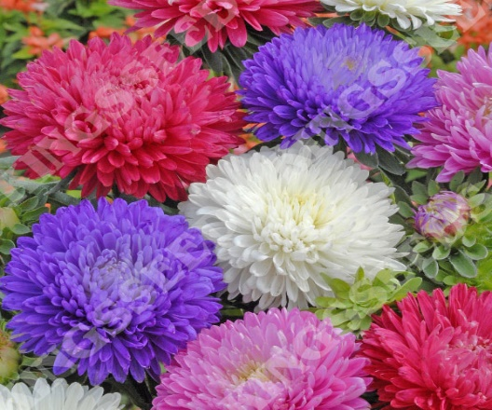

**Aster**

(Callistephus chinensis)

The Aster is an annual flowering plant in the Asteraceae (daisy) family, native to China and were introduced to Europe in the 18th century, widely cultivated for its showy flowers. Asters are grown as annuals, typically flowering in summer and autumn.

•**HARDINESS** Half hardy.

•**CULTIVATION** Grow Asters in well-drained, fertile soil enriched with organic matter. Plant in full sun for best flowering; Asters require at least 6-8 hours of direct sunlight daily. Keep the soil evenly moist, water regularly during dry periods. Asters vary in size depending on the cultivar, ranging from compact varieties to tall types suitable for cutting. Flowers July-September.

•**PROPAGATION**

**Seeds:** Start Asters from seeds sown indoors in early spring or directly in the garden after the last frost.

**Transplanting:** Asters can also be purchased as seedlings and transplanted into the garden.

•**PESTS AND DISEASES** Prone to aster wilt, cucumber wilt, tomato spotted wilt, aphids, and cutworm.

•**USES**

**Ornamental:**

Asters are prized for their profusion of daisy-like flowers that come in a range of colours, including white, pink, purple, blue, and red. They are popular in borders, beds, containers, and cutting gardens for their long-lasting blooms.

**Cut Flowers:** Asters make excellent cut flowers, adding a cheerful touch to bouquets and floral arrangements. They can be used fresh or dried for indoor decorations.

**•OTHER BENEFITS**

**Pollinator Friendly:** Aster flowers attract bees, butterflies, and other pollinators to the garden.

**Late Season Interest:** Asters bloom in late summer and autumn, providing colour when many other plants are fading.