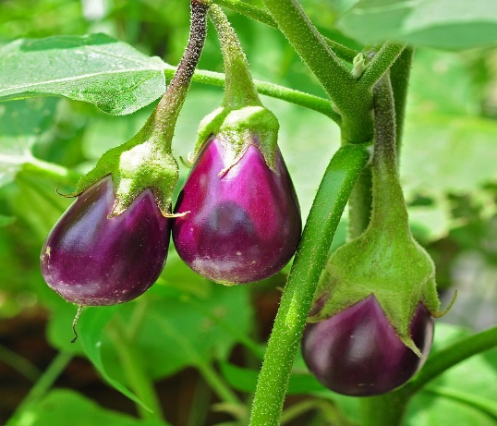

**Aubergine** (Eggplant)

(Solanum melongena)

Aubergine is a species of flowering plant native to the Indian subcontinent and has been cultivated across Asia, Africa, and Europe. Aubergine is a tender perennial plant grown as an annual in most regions, thriving in warm climates, now cultivated worldwide for its edible fruits.

•**HARDINESS** Frost tender

•**CULTIVATION** Grow aubergines in well-drained, fertile soil enriched with organic matter; a slightly acidic to neutral pH is preferred. Plant in full sun for best growth and fruiting; aubergines require at least 6-8 hours of direct sunlight daily. Keep the soil consistently moist but not waterlogged, water deeply and regularly, especially during hot and dry periods. Aubergine plants can vary in size from compact varieties suitable for containers to larger, bushy types.

•**PROPAGATION**

**Seeds:** Start aubergines from seeds indoors 8-10 weeks before the last frost date; transplant seedlings into the garden or containers after all danger of frost has passed.

**Transplanting:** Aubergine seedlings can also be purchased and transplanted directly into the garden or containers.

•**PESTS AND DISEASES** Prone to aphids, red spider mites, tomato spotted wilt, and grey mould (Botrytis) under glass.

•**USES**

**Edible Fruits:** Aubergines produce elongated or round fruits in various colours, including purple, black, white, and striped varieties. They are used in a variety of cuisines, especially Mediterranean and Asian, in dishes like ratatouille, moussaka, curries, and stir-fries.

•**OTHER BENEFITS**

**Nutritional Value:** Aubergines are low in calories and rich in dietary fibre, vitamins (especially vitamin K), minerals, and antioxidants.

**Culinary Versatility:** Aubergines can be grilled, roasted, sautéed, or fried, offering a range of textures and flavours in cooking.