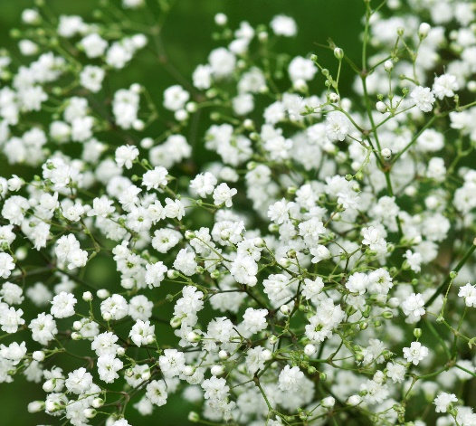

**Baby's Breath**

(Gypsophila spp.)

Baby's Breath is a genus of flowering plants in the Caryophyllaceae (carnation) family, consisting of annuals and perennials with fine, branching stems and tiny flowers. Baby's Breath species are native to Europe, Asia, and North Africa.

•**HARDINESS** Fully hardy to frost hardy.

•**CULTIVATION** Grow Baby's Breath in well-drained, neutral to alkaline soil. Plant in full sun for best flowering; Baby's Breath prefers direct sunlight. Keep the soil moderately moist, water regularly during dry periods. Baby's Breath plants vary in size, with some compact varieties suitable for borders and others used for cutting. Flowers June-October.

•**PROPAGATION**

**Seeds:** Start Baby's Breath from seeds sown directly in the garden after the last frost.

**Division:** Perennial Baby's Breath can be propagated by dividing mature clumps in early spring.

•**PESTS AND DISEASES** Stem rots may be a problem.

•**USES**

**Ornamental:** Baby's Breath is prized for its profusion of tiny, white, or pink flowers that add a soft, airy texture to floral arrangements. It is commonly used as a filler in bouquets, centrepieces, and wedding decorations.

**Cut Flowers:** Baby's Breath flowers are long-lasting and make excellent additions to fresh and dried flower arrangements. They complement a wide range of flower types and colours in mixed bouquets.

•**OTHER BENEFITS**

**Attracts Beneficial Insects:** Baby's Breath flowers attract beneficial pollinators like bees and butterflies to the garden.

**Drought Tolerant:** Some species of Baby's Breath are tolerant of dry conditions once established.