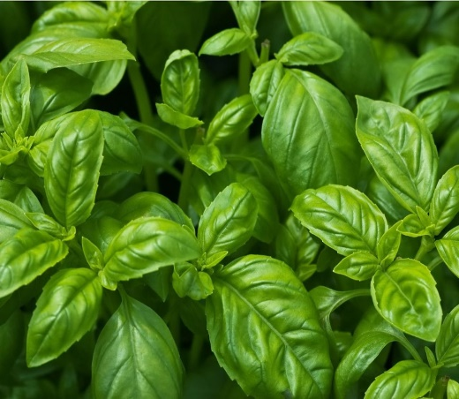

**Basil**

(Ocimum basilicum)

Basil is an annual and evergreen perennials and shrubs known for its aromatic leaves and culinary uses. It comes in various cultivars with distinct flavours and appearances. Basil is native to tropical regions of Asia, particularly India and Southeast Asia.

**•HARDINESS** Half hardy to frost tender.Basil is typically grown as an annual in most climates.

**•CULTIVATION** Grow basil in well-drained, fertile soil with good organic matter. Plant in full sun for best growth and flavour. Keep the soil consistently moist, especially during hot weather. Pinch out flower heads to ensure continued leaf growth. Basil plants can range from compact to bushy, depending on the variety.

**•PROPAGATION**

**Seeds:** Start basil from seeds indoors or sow directly in the garden after the last frost.

**Cuttings:** Basil can be propagated from stem cuttings placed in water or moist soil.

**•PESTS AND DISEASES** May be infested with aphids, and sometimes effected by mildew in hot, dry summers.

**•USES**

**Culinary:** Basil leaves are used fresh or dried in a variety of dishes, including Italian cuisine (e.g., pesto), salads, pasta, and pizzas. Different basil cultivars offer unique flavours, such as sweet basil, Thai basil, and lemon basil.

**Medicinal:** Basil is valued in traditional medicine for its anti-inflammatory and antimicrobial properties. It may support digestion, respiratory health, and overall wellness.

•**OTHER BENEFITS**

**Aromatic Plant:** Basil emits a pleasant fragrance that repels certain pests and adds ambiance to gardens.

**Companion Planting:** Plant basil near tomatoes, peppers, and other vegetables to enhance growth and repel pests.