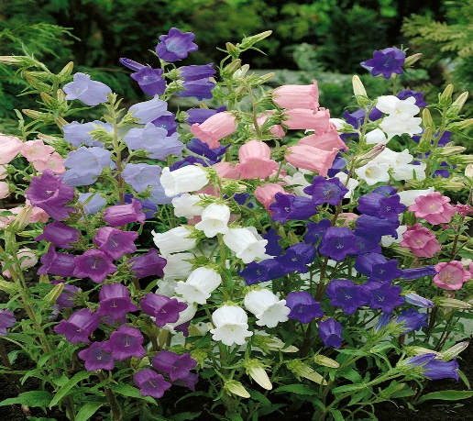

**Bellflower**

(Campanula spp.)

Campanula is a genus of herbaceous perennials and annuals, comprising a wide range of species with varying growth habits and flower forms. Campanula species are native to temperate regions of the Northern Hemisphere, including Europe, Asia, and North America.

•**HARDINESS** Fully hardy to frost tender.

•**CULTIVATION** Grow Campanula in well-drained, fertile soil with good organic matter. Most Campanula species prefer full sun to partial shade; some varieties thrive in shade. Keep the soil consistently moist, water regularly during dry periods. Campanula plants vary widely in size, from low-growing ground covers to tall, upright species. Taller species may require staking. Flowers June-August.

•**PROPAGATION**

**Seeds:** Start Campanula from seeds sown indoors in early spring or directly in the garden after the last frost.

**Division:** Perennial Campanula can be propagated by dividing mature clumps in spring or fall.

•**PESTS AND DISEASES** Vulnerable to slugs, snails, aphids, and red spider mites.

•**USES**

**Ornamental:** Campanula is prized for its bell-shaped flowers that come in various colours, including blue, purple, pink, and white. It is commonly used in borders, rock gardens, containers, and cottage-style landscapes for its charming appearance.

**Cut Flowers:** Some Campanula species are suitable as cut flowers, adding a delicate touch to floral arrangements. Bellflowers are often used in mixed bouquets or as standalone blooms.

**•OTHER USES**

**Wildlife Attraction:** Campanula flowers attract pollinators like bees and butterflies to the garden.

**Adaptability:** Campanula species are versatile and can thrive in different garden settings, from sunny borders to shaded woodland areas.