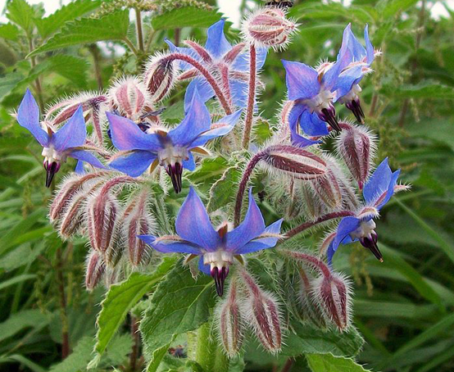

**Borage**

(Borago officinalis)

Borage is an annual herbaceous plant in the Boraginaceae family, native to the Mediterranean region but cultivated worldwide. Borage is native to the Mediterranean region, including parts of Europe and North Africa. Borage is typically grown as an annual but may self-seed in favourable conditions.

•**HARDINESS** Fully hardy to frost hardy

•**CULTIVATION** Grow borage in well-drained, fertile soil with good organic matter. Plant in full sun for best growth and flowering. Keep the soil consistently moist, especially during hot weather. Borage plants can reach a height of 2 to 3 feet (60 to 90 cm) and spread about 1 to 2 feet (30 to 60 cm). Flowers June-September.

•**PROPAGATION**

**Seeds:** Start borage from seeds directly sown in the garden after the last frost.

**Self-Seeding:** Borage readily self-seeds, producing new plants in subsequent growing seasons.

•**PESTS AND DISEASES** Susceptible to powdery mildew.

•**USES**

**Culinary:** Borage leaves and flowers are edible and used as a garnish in salads, soups, and beverages. The flowers have a mild cucumber-like flavour, making them a refreshing addition to dishes.

**Medicinal:** Borage is valued in herbal medicine for its anti-inflammatory and diuretic properties. The leaves and flowers may be used to support skin health and reduce inflammation.

•**OTHER BENEFITS**

**Attracts Pollinators:** Borage flowers attract bees, butterflies, and other beneficial pollinators to the garden.

**Companion Planting:** Plant borage near tomatoes, squash, and strawberries to enhance pollination and deter pests.