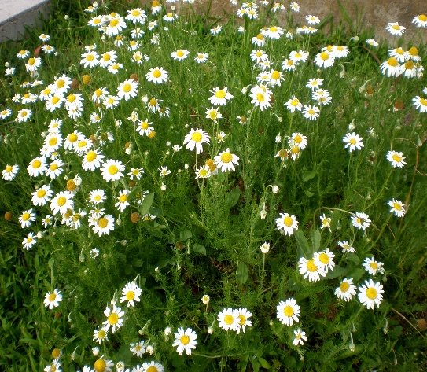

**Chamomile**

(Chamaemelum nobile)

Chamomile is a low-growing perennial herb in the Asteraceae (daisy) family, prized for its daisy-like flowers and soothing fragrance. Chamomile is native to Europe and Western Asia and is now widespread across North and Soth America.

•**HARDINESS** Fully hardy

•**CULTIVATION** Grow chamomile in well-drained, sandy soil with good drainage. Plant in full sun to partial shade. Keep the soil evenly moist but not waterlogged. Chamomile plants typically reach a height of 6 to 12 inches (15 to 30 cm). Flowers June-September.

•**PROPAGATION**

**Seeds:** Start chamomile from seeds sown directly in the garden in spring or fall.

**Division:** Divide mature plants in early spring to propagate.

•**PESTS AND DISEASES** Trouble free

•**USES**

**Culinary:** Chamomile flowers are used to make a soothing herbal tea, often enjoyed for relaxation and sleep. The flowers can also be used in cooking and baking to add a mild, floral flavour.

**Medicinal:** Chamomile is renowned for its calming and anti-inflammatory properties. It is used in herbal medicine to promote relaxation, relieve stress, aid digestion, and soothe skin irritations.

**Aromatic:** Chamomile has a pleasant, apple-like fragrance that can be enjoyed in gardens and landscapes.

•**OTHER BENEFITS**

**Companion Planting:** Plant chamomile near vegetables and herbs to attract beneficial insects and repel pests.

**Natural Insecticide:** Chamomile tea can be used as a natural insecticide spray to deter pests from plants.