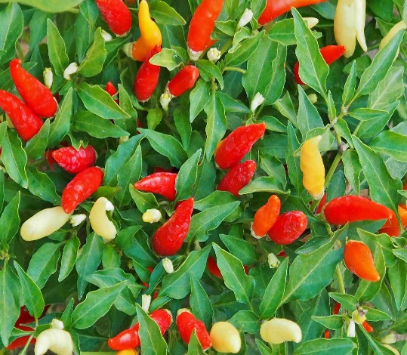

**Chili Pepper**

(Capsicum spp.)

Chili peppers are perennial plants grown as annuals in most regions, prized for their spicy fruits and ornamental value. Chili peppers are native to the Americas, particularly Central and South America.

•**HARDINESS** Frost tender.

•**CULTIVATION** Grow chili peppers in well-drained, fertile soil enriched with organic matter; a slightly acidic to neutral pH is ideal. Plant in full sun for best growth and fruiting; chili peppers require at least 6-8 hours of direct sunlight daily. Keep the soil consistently moist but not waterlogged, water regularly, especially during hot and dry periods. Pinch out the growing tips of young plants to promote branching. Chili pepper plants vary in size from compact varieties suitable for containers to larger, bushy types.

•**PROPAGATION**

**Seeds:** Start chili peppers from seeds indoors 8-10 weeks before the last frost date; transplant seedlings into the garden after all danger of frost has passed.

**Transplanting:** Chili pepper seedlings can also be purchased and transplanted directly into the garden or containers.

•**PESTS AND DISEASES** Susceptible to viruses, fungal wilt, anthracnose, and powdery mildew. Red spider mites and aphids may be a problem.

•**USES**

**Edible Fruits:** Chili peppers produce a wide range of fruits with varying heat levels, flavours, and colours, including jalapeños, habaneros, cayenne, and bell peppers. They are used fresh in salsas, sauces, and dishes, as well as dried and ground into chili powder or flakes.

•**OTHER BENEFITS**

**Culinary Versatility:** Chili peppers add spice and flavour to a variety of cuisines, including Mexican, Thai, Indian, and more.

**Ornamental Value:** Many chili pepper varieties have attractive fruits and foliage, making them popular for ornamental gardens and container plantings.