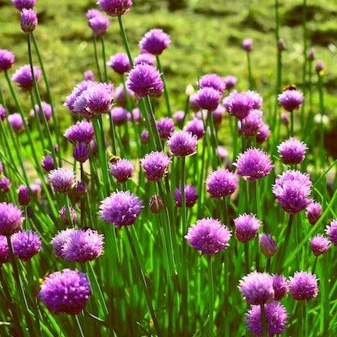

**Chives**

(Allium schoenoprasum)

Chives are herbaceous perennial plants belonging to the Allium genus, which also includes onions, garlic, and leeks. Chives are native to Europe, Asia, and North America. Chives are perennial herbs that return each year from underground bulbs or rhizomes.

•**HARDINESS** Full hardy to frost hardy.

•**CULTIVATION** Grow chives in well-drained, fertile soil with good organic matter. Plant in full sun to partial shade, chives tolerate shade but thrive in sunlight. Keep the soil consistently moist, water during dry spells. typically grow to a height of 12 to 18 inches (30 to 45 cm).

•**PROPAGATION**

**Division:** Propagate chives by dividing clumps of mature plants in early spring or fall.

**Seeds:** Start chives from seeds sown directly in the garden or indoors for early planting.

•**PESTS AND DISEASES** Susceptible to white rot, downy mildew, and onion fly.

•**Uses**

**Culinary:** Chives are used fresh as a mild onion-flavoured herb in salads, soups, dips, and garnishes. They add a subtle onion taste and vibrant green colour to dishes.

**Medicinal:** Chives have mild antibacterial properties and may support digestive health. They are also rich in vitamins and minerals, including vitamin C and potassium.

•**OTHER BENFITS**

**Ornamental Value:** Chives produce attractive lavender-pink flowers in spring and summer, attracting pollinators.

**Companion Planting:** Plant chives near vegetables to deter pests like aphids and carrot flies.

**Container Growing:** Chives thrive in containers and can be grown indoors year-round.