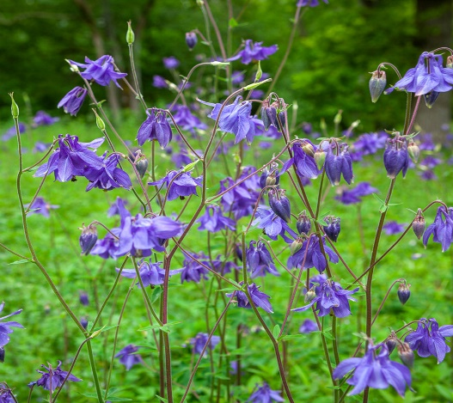

**Columbine**

(Aquilegia spp.)

Columbine is a genus of herbaceous perennial plants in the family Ranunculaceae, native to temperate regions of the Northern Hemisphere such as North America, Europe, and Asia. Columbine is a perennial plant, meaning it regrows each year from the same roots.

•**HARDINESS** Fully hardy.

•**CULTIVATION** Grow Columbine in well-drained, fertile soil with good organic matter; it prefers slightly acidic to neutral pH. Plant in partial shade to full sun; Columbine tolerates shade but flowers best with some direct sunlight. Keep the soil evenly moist, water regularly during dry periods, especially in summer. Columbine plants vary in size, with heights ranging from 1 to 3 feet (30 to 90 cm) depending on the species and cultivar. Flowers May-July.

•**PROPAGATION**

**Seeds:** Start Columbine from seeds sown indoors in early spring or directly in the garden in autumn for germination the following spring.

**Division:** Columbine can also be propagated by dividing mature clumps in early spring or fall.

•**PESTS AND DISEASES** Susceptible to powdery mildew, aphids, leaf miners, sawflies, and caterpillars.

•**USES**

**Ornamental:** Columbine is prized for its distinctive, spurred flowers that come in a range of colours, including blue, purple, pink, yellow, and white. It is popular in woodland gardens, cottage gardens, and rock gardens for its natural charm and delicate appearance.

**Cut Flowers:** Columbine flowers are attractive in floral arrangements, adding a whimsical touch to bouquets. They have a long vase life and can be enjoyed indoors. The flowers are also edible, but the rest of the plant contains toxins and should not be consumed.

•**OTHER BENEFITS**

**Attracts Pollinators:** Columbine flowers are attractive to bees, butterflies, and hummingbirds, making them valuable for pollinator gardens.