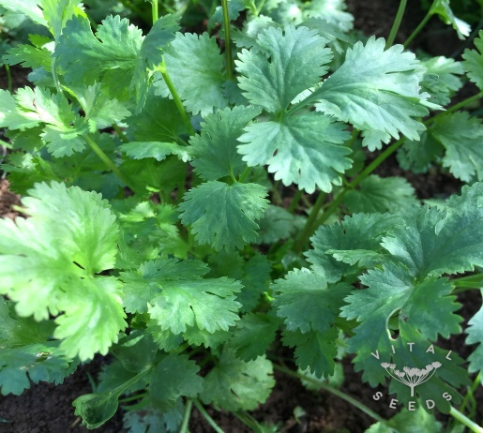

**Coriander**

(Coriandrum sativum)

Coriander is an annual herb in the Apiaceae family known for its aromatic leaves and seeds, both of which are widely used in cooking. Coriander is believed to have originated in the Mediterranean region and is now cultivated worldwide. Coriander is grown as an annual (grown for leaves) or biennial (grown for seeds).

•**HARDINESS** Fully hardy.

•**CULTIVATION** Grow in well-drained, fertile soil with a pH of 6.2 to 6.8. Plant in full sun to partial shade. Keep the soil consistently moist but not waterlogged. Coriander prefers cool temperatures and may bolt in hot weather.

•**PROPAGATION**

**Seeds:** Sow seeds directly in the garden after the last frost or start indoors for early planting.

**Succession Planting:** Sow seeds every few weeks for continuous harvest of leaves.

**Harvesting Seeds:** Allow plants to flower and produce seeds (coriander seeds) in the second year or late in the growing season.

•**PESTS AND DISEASES** Susceptible to fungal wilt.

•**USES**

**Culinary**: Leaves are used fresh in salads, salsas, curries, and soups, these add a fresh, citrusy flavour to dishes. Seeds are used whole or ground in spice blends, pickling, and baking. Coriander seeds have a warm, citrusy flavour with earthy undertones.

**Medicinal:** Coriander is used in traditional medicine for its digestive and anti-inflammatory properties. It is believed to aid digestion and promote overall wellness.

•**OTHER BENEFITS**

**Attracts Beneficial Insects:** Coriander flowers attract beneficial insects such as bees and hoverflies to the garden.

**Companion Planting:** Planting coriander near other herbs and vegetables can help deter pests.