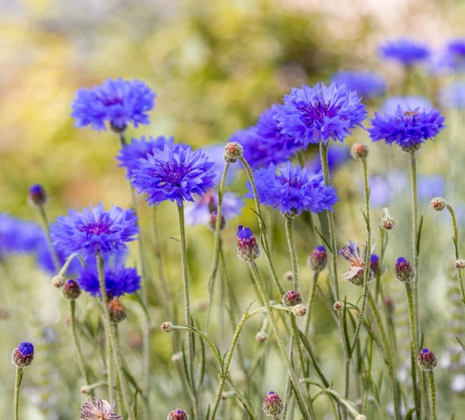

**Cornflower**

(Centaurea cyanus)

Cornflower is an annual flowering plant in the Asteraceae (daisy) family, native to Europe, particularly in regions with temperate climates, and commonly cultivated for its attractive blue blooms. Cornflower is an annual plant, meaning it completes its lifecycle in one growing season.

•**HARDINESS** Fully hardy to frost hardy.

•**CULTIVATION** Grow Cornflower in well-drained, sandy to loamy soil with good drainage. Plant in full sun for best flowering; Cornflower thrives in sunny locations. Keep the soil moderately moist, water regularly during dry periods. Cornflower plants typically grow to heights of 1 to 3 feet (30 to 90 cm), depending on the variety. Flowers June-September.

•**PROPAGATION**

**Seeds:** Start Cornflower from seeds sown directly in the garden after the last frost.

**Naturalizing:** Cornflower readily self-seeds, and once established, it may naturalize in the garden.

•**PESTS AND DISEASES** Powdery mildew may be a problem.

•**USES**

**Ornamental:** Cornflower is valued for its beautiful blue flowers, which attract pollinators like bees and butterflies. It's often used in wildflower meadows, cottage gardens, and as a cut flower in floral arrangements.

**Cultural Significance:** Cornflower holds cultural significance in some European countries, where it is considered a symbol of remembrance and national identity.

**Edible Flowers:** Cornflower petals are edible and can be used to garnish salads, desserts, and beverages.

•**OTHER BENEFITS**

**Wildlife Habitat:** Cornflower flowers provide nectar and pollen for beneficial insects and pollinators.

**Low Maintenance:** Cornflower is easy to grow and requires minimal care once established.