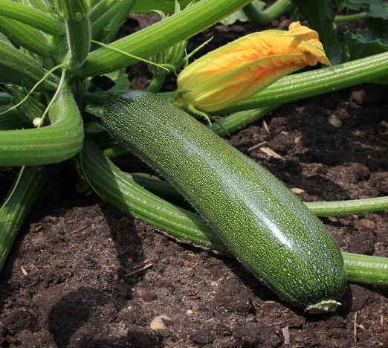

**Courgette**

(Cucurbita pepo)

Courgette is a variety of summer squash known for its tender fruits and vigorous growth during the warm season. Courgette is believed to have originated in Central America and Mexico but is now cultivated worldwide. Courgette is an annual plant grown for its fruits, which are harvested while immature and tender.

•**HARDINESS** Fully hardy to frost tender.

•**CULTIVATION** Grow courgettes in well-drained, fertile soil rich in organic matter; a slightly acidic to neutral pH is preferred. Plant in full sun for best growth and fruiting; courgettes require at least 6-8 hours of direct sunlight daily. Keep the soil consistently moist but not waterlogged, water deeply and regularly, especially during hot and dry periods. Courgette plants are bushy and compact, spreading out as they grow and producing abundant fruits.

•**PROPAGATION**

**Seeds:** Start courgettes from seeds directly sown in the garden after the last frost date; seeds can also be started indoors and transplanted later.

**Transplanting:** Courgette seedlings can be transplanted into the garden once the soil has warmed up and all danger of frost has passed.

•**PESTS AND DISEASES** Slugs and snails can eat seedlings and young plants, and sometimes flowers and young fruits too, especially in damp weather. Powdery mildew can also be a problem in damp conditions.

•**USES**

Edible Fruits: Courgettes produce elongated, cylindrical fruits with tender skins and mild flavour. They are used in salads, stir-fries, sautés, grilled dishes, and baked goods like zucchini bread.

•**OTHER BENEFITS**

**Nutritional Value:** Courgettes are low in calories and rich in water content, dietary fibre, vitamins (especially vitamin C), and minerals.

**Versatile Cooking Ingredient:** Courgettes can be cooked in various ways and used as a substitute for pasta in dishes like zoodles (zucchini noodles).