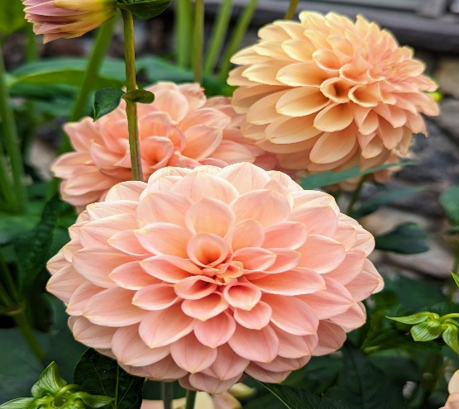

**Dahlia**

(Dahlia spp.)

Dahlias are herbaceous perennial plants in the Asteraceae (daisy) family, prized for their vibrant and varied flower forms. Dahlias are native to Mexico and Central America. Dahlias are grown from tuberous roots and can be treated as annuals in colder climates.

•**HARDINESS** Frost hardy to frost tender.

•**CULTIVATION** Grow dahlias in well-drained, fertile soil with good organic matter. Plant in full sun for best flowering, dahlias require at least 6-8 hours of direct sunlight daily. Keep the soil evenly moist; water deeply during dry periods but avoid waterlogged conditions. Dahlias vary in size depending on the cultivar, ranging from dwarf varieties to large dinner-plate blooms. Flowers July onwards.

•**PROPAGATION**

**Tubers:** Dahlias are propagated from tuberous roots, which can be divided and replanted in spring.

**Cuttings:** Dahlias can also be propagated from stem cuttings taken from actively growing plants.

•**PESTS AND DISEASES** Aphids, capsid bugs, red spider mites, caterpillars, earwigs, and slugs may be troublesome. Also prone to powdery mildew, mosaic virus, tomato spotted wilt virus, and rotting of tubers when stored.

•**USES**

**Ornamental:** Dahlias are grown primarily for their stunning flowers, which come in a wide range of colours, shapes, and sizes. They are popular in gardens, borders, and floral arrangements due to their long-lasting blooms.

**Cut Flowers:** Dahlias are prized as cut flowers, ideal for bouquets and floral displays. They make excellent additions to wedding arrangements and special occasion floral designs.

•**OTHER BENEFITS**

**Pollinator Friendly:** Dahlia flowers attract bees, butterflies, and hummingbirds to the garden.

**Variety:** With thousands of cultivars available, dahlias offer endless possibilities for gardeners to explore different colours and forms.