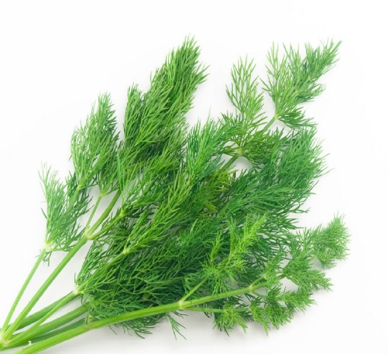

**Dill**

(Anethum graveolens)

Dill is an annual or biennial herb in the celery family Apiaceae. It is native to S.W. Asia and India and is known for its feathery leaves and flavourful seeds.

•**HARDINESS** Fully hardy.

•**CULTIVATION** Grow in fertile, well drained soil in full sun with shelter from strong winds. Water freely during growing season to inhibit bolting.

•**PROPAGATION**

**Seeds:** Directly sow seeds in the garden in spring after the last frost. Dill does not transplant well due to its long taproot.

•**PESTS AND DISEASES** Trouble free.

•**USES**

**Culinary:** Leaves are used fresh as an herb in salads, dips, and with fish dishes. Seeds are used whole or ground in pickling and cooking.

**Medicinal:** Used traditionally for digestive issues, such as bloating and gas. Contains antioxidants and may have antimicrobial properties.