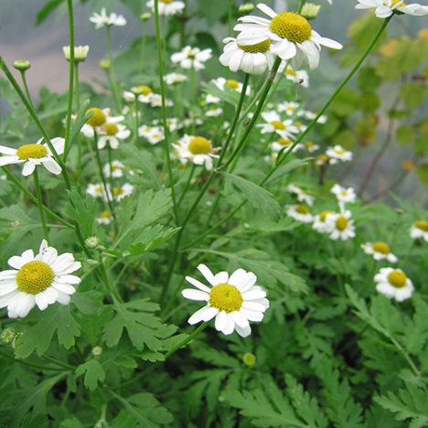

**Feverfew**

(Tanacetum parthenium)

Feverfew is an herbaceous perennial plant in the Asteraceae (daisy) family, native to Europe, particularly the Balkan Peninsula and is widely cultivated for its medicinal properties. Feverfew is an herbaceous perennial, but it is often grown as an annual in colder climates.

•**HARDINESS** Fully hardy to half hardy.

•**CULTIVATION** Grow in well drained, preferably sandy soil in full sun or partial shade. Keep the soil consistently moist but not waterlogged. Feverfew plants typically reach heights of 1 to 2 feet (30 to 60 cm).

•**PROPAGATION**

**Seeds:** Start Feverfew from seeds sown directly in the garden in spring or early winter.

**Division:** Propagate mature plants by dividing clumps in spring or early autumn.

•**PESTS AND DISEASES** Aphids, chrysanthemum eelworm, and leaf miners may be a problem.

•**USES**

**Medicinal:** Feverfew is primarily used in herbal medicine to treat migraines and headaches. It contains compounds that may have anti-inflammatory and pain-relieving properties. Feverfew is also used for fever reduction, arthritis, menstrual disorders, and digestive issues.

**Culinary:** While traditionally used medicinally, Feverfew is not commonly used in culinary dishes due to its bitter taste.

•**OTHER BENEFITS**

**Ornamental Value:** Feverfew produces clusters of small, daisy-like flowers with white petals and yellow centres, making it a charming addition to herb gardens and borders.

**Companion Planting:** Plant Feverfew near roses to deter aphids and attract beneficial insects.

•**PRECAUTIONS**

**Caution:** Feverfew may cause allergic reactions in some individuals.

**Consultation:** Consult with a healthcare professional before using Feverfew for medicinal purposes, especially if pregnant, nursing, or taking other medications.