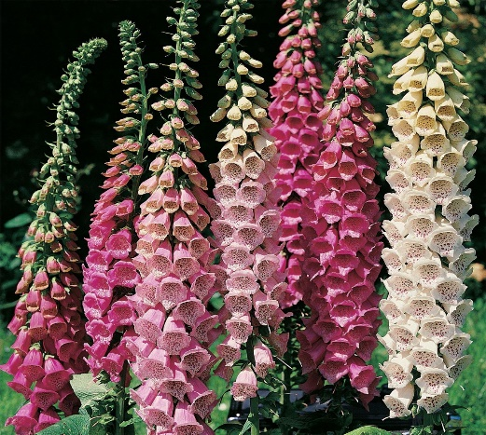

**Foxglove**

(Digitalis spp.)

Foxglove is a genus of flowering plants in the family Plantaginaceae (formerly Scrophulariaceae), native to the British Isles, Europe, Asia, and North Africa. The most common species is Digitalis purpurea. Foxglove is typically grown as a biennial, meaning it completes its lifecycle over two years. It produces foliage in the first year and blooms in the second year before setting seed and declining.

•**HARDINESS** Fully hardy to frost hardy.

•**CULTIVATION** Grow in almost any soil, except very wet or very dry. Most prefer humus-rich soil in partial shade. Keep the soil consistently moist but not waterlogged; water during dry periods to maintain adequate moisture. Foxglove plants can reach heights of 3 to 5 feet (0.9 to 1.5 meters) or more, depending on the variety. Flowers June onwards.

•**PROPOGATION**

**Seeds:** Start Foxglove from seeds sown indoors in late winter for planting out in spring, or sow directly in the garden in late spring.

•**PESTS AND DISEASES** Susceptible to leaf spot and powdery mildew.

•**USES**

**Ornamental:** Foxglove is prized for its dramatic spires of tubular flowers that come in shades of pink, purple, white, and occasionally yellow and peach. It adds vertical interest to borders, woodland gardens, and cottage-style landscapes.

**Wildlife Attraction:** The nectar-rich flowers of Foxglove attract bees and butterflies to the garden.

•**OTHER BENEFITS**

**Self-Seeding:** Foxglove readily self-seeds in favourable conditions, allowing it to naturalize and return year after year in suitable climates.

**Caution:** Note that Foxglove is toxic if ingested, so it should be planted away from areas where children and pets play and handled with care.