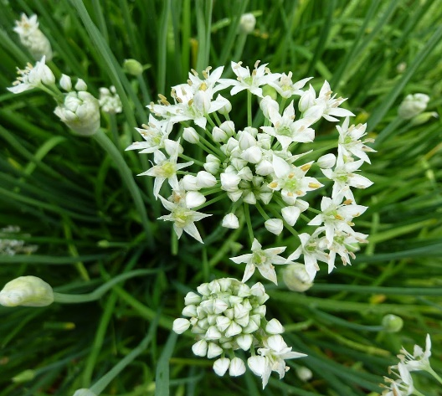

**Garlic Chives**

(Allium tuberosum)

Garlic Chives, also known as Chinese Chives or Chinese Leeks, are a bulbous perennial plant in the onion family (Amaryllidaceae) known for their mild garlic flavour. Garlic Chives are native to East Asia, including China and surrounding regions.

•**HARDINESS** Fully hardy to frost hardy.

•**CULTIVATION** Grow in fertile, well drained soil in full sun. Water regularly, especially during dry periods. Divide clumps every few years to maintain plant vigour.

•**PROPOGATION** Sow seed in containers in a cold frame, in spring. Garlic Chives can also be grown from individual bulb divisions.

•**PESTS AND DISEASES** Susceptible to white rot, downy mildew, and onion fly.

•**USES**

**Culinary:** Leaves and flowers are used as a flavouring herb in various Asian cuisines. Adds a mild garlic flavour to stir-fries, dumplings, soups, and salads.

**Medicinal:** Traditionally used in herbal medicine for digestive health and to stimulate appetite. Contains beneficial nutrients and antioxidants.

•**OTHER BENEFITS**

**Ornamental Value:** Garlic Chives produce attractive white flowers in late summer, attracting pollinators to the garden.

**Permaculture Plant:** Can be grown as a perennial food crop in permaculture gardens, providing year-round harvests.